OUT of ORDER

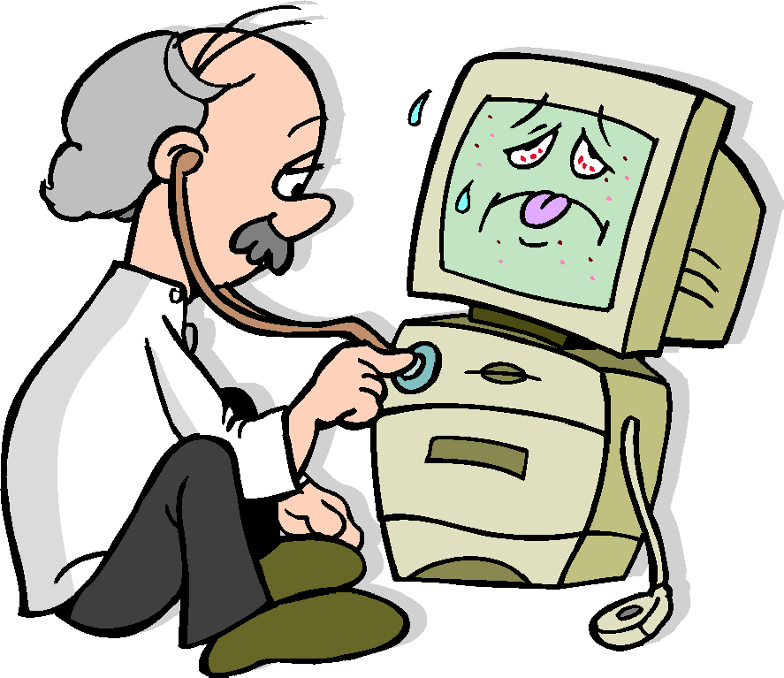

Our apologies!

problem: ________________________

expected date of repair: _______

Thank you for your patience.
Notes from the talk

The best defense is a good DIP!
Documentation -- where is it?
Internet policy -- where is it?
Passwords -- where are they?

Establish a baseline normal
1) set expectations
2) communicate the current state of affairs
3) fix whatever's immediately broken, or try
4) work to fix the meta problem in the future

Appearances matter
- do your computers tell the right time?
- flat screens = modern!
- clean keyboards and mice
- give patrons enough room for book/writing/whatever
- give patrons headphones or place to put them
- give patrons a USB plug or place to put them
- make sure these are current
- operating system
- browser(s)
- plug-ins (flash, shockwave, adobe)
- drivers
- office tools

Envision your model patrons and how their needs vary
- high expertise, low expectation
- high expertise high expectation
- low expertise, low expectation
- low expertise, high expectation

First Steps, Ask
* "Explain the problem in your own words."
* "What were you doing when this happened?"
* "What are you trying to do?"
* As you do this, remember our model patrons, try to gauge who you are dealing with.
* Determine: is it time for.... CTRL ALT DEL? (command - option - escape)

PEBKAC, explained
* Is the patron having an anger, fear or confusion-based response to the problem? do you need to deal with that first?
* Standard failure modes [is the window off the screen? did they click in another window? did a pop-up obscure their window? do they have more than one window open? did they move the start bar someplace crazy?]
* Windows failure modes (not strickly PEBKAC)
Hardware troubleshooting
The basic troubleshoot is to replace each cable one at a time with known working cables until you've isolated the problem, if you can. Do you know who to call if there is a problem outside your immediate area, upstream provider? ISP?
* check other computers - what's going on nearby? quick scan.
* check power buttons?
* check cables and cords?
* how responsive is the computer?
* catastrophe? [mother's day busy signal]

Software troubleshooting
* What is the ENTIRE error message, all of it, yes ALL of it. Write it down.
* Can you explain the problem?
* Is this a software support issue? [How do you deal with those?]
* Is this a system-specific failure mode? [firewall? system protection issue? "not enough privileges" issue?]

Basic Troubleshooting
* Reality testing "Is this a thing I think a computer can do?" "Is this a thing I think our computers can do?"
* Google it, seriously. This is where that error message comes in handy.
* Where do preferences hide? [Internet: control panel, and network, in addition to being in IE. Word: tools > options/customize. What else is in the control panel? printers, users, network, system (drivers), display (desktop images), add/remove programs, date/time]
* Software/Hardware support forums, both kinds. Don't do support for things that have other systems to support them.
o Official: Microsoft, Apple, Hewlett Packard
o Unofficial: Annoyances.org (Windows), Mac OSX hints
o Chatty: web4lib, code4lib, publib, IM someone?

Troubleshooting: The Web
* "My Yahoo is broken."
know how to debug an email address and a web address and a link: NO SPACES, no funny characters except the @, the little squiggle is a tilde, standard endings for URLs and email
* "Where's my web page?"
look for error codes: 404, 401, &c.
look for common URL spellings and know how your browser deals with them (IE may search from the address bar, for example)
look for capitalization
look for broken links if someone's clicking through from an email
* "What am I supposed to do here?"
remember that new users read every web page all the way through
try to teach them to look for action buttons or links
you are not responsible for all the bad web design in the world.
* Reality testing: "My bank needs me to enter my social security number...." "I want to sell this on Ebay in 45 minutes."
How to mouseover a link to see where it really goes
What is phishing
Troubleshooting: Uploading/Downloading
* "Nothing happened"
popup blocker, do you even allow downloading?
is there a hidden "save as" window someplace]
* "Where is my file?"
well what's it called?
where did you put it?
set default downloads location that isn't the INTERNET cache.
sometimes you can look on the Documents menu.
Search by time when all else fails
* "My attachment won't attach"
attaching takes time and usually one too many steps,
sometimes you need to know the letter of the drive if you're using a firewallish thing like Deep Freeze
yes you have to click "open" to attach something, no it makes no sense.
* "This attachment is like a brick on my desktop!"
explain the "must have application" aspects to attachments

Troubleshooting: Microsoft Word
* "The computer keeps changing what I type" [is autocorrect turned on? autoformatting? remember to check both places]
* "It says go to file print but there IS NO FILE PRINT." [menu hiding? disable that entirely if you can, make sure they understand three step menus. the printbutton does NOT do what the print command does]
* "Make that paper clip go away forever." [the office assistant can be hid one time, per session, generally, or removed entirely from your word install]

Troubleshooting: Printers (note: a lot of this varies depending on the printer)
* "I want to print just what I'm looking at."
make sure they get that a web page is just one big long page
check to see if you have a "print selection" option
* "My document doesn't fit on the page."
see if there is a "print this page" option
there should be a way to scale pages when printing, usually by percentages or just "fit on page"
sometimes you can span multiple pages, sometimes this just won't work
* "I can't afford all these pages."
2-up printing! hard to read but saves paper
Computer 911
steps to take before you call for help

90% of all repairable tech support problems can be solved by a "do over" This means...

- seeing what he last thing was that you did before the problem started
- looking to see if the computer is asking you a question, and answering it
- restarting the program you are working on (you may lose your unsaved work)
- making sure everything is still plugged in
- turning the computer on and off again (ten second power button trick)

The other 10% are usually a combination of

- hardware problems
- software conflicts
- incorrect or problematic system or software settings
- gremlins (actually, no)

Occasionally something really breaks

- computers should NOT smell like anything
- they should not make clicking or clunking noises
- they do not like coffee, sudden movements or lots of dust
- if everyone seems to be off the network you do not have to troubleshoot your own network problems, for example.

What you should make note of if you do need to ask for help

- are you the only person having this problem or is it affecting everyone?
- what were you doing before the problem happened
- what happened, or what didn't happen?
- what were you expecting to happen?
- the text of the error message you got, if any
- what steps you took to try to fix the problem and what happened.
- what computer you were using and what, if any, login you were using.
Things You Can Do

Look at support websites

- http://support.microsoft.com
- http://apple.com/support
- http://www.annoyances.org
- http://forums.macrumors.com
- or just Google it! Use the help files to make sure you're using the correct terminology.

Talk to your colleagues

- Have they dealt with the same problems?
- How did they handle it?
- Did it work?

Know what's possible, and how

- "A printer should be able to...."
- "A web site should be able to"
- "Microsoft Word should be able to...."
- "Microsoft Excel should be able to...."

Know what's prevented, and why

- "What does the filtering software filter?"
- "Is there a wireless network that I can use?"
- Don't trust people who say the computer has "issues."
- Tech support problems are not magic. Repeatable problems should also be explainable.

Have a system

- Troubleshooting involves testing each part of the equation in turn to try to isolate what is causing the problem. Keep a list.
- Keep a log of whether these problems happen at similar times or under similar circumstances.
- Ask for a timeline for when larger problems will be fixed.
- Have standard reporting for Out of Order signage

